LAB ASSIGNMENT-18.3
Task 1 – Movie Database API
Task: Connect to a Movie Database API (e.g., OMDb or TMDB) to fetch details of a movie.
Instructions:
Prompt AI to generate Python code to query the API by movie title.
Handle errors like invalid movie name, missing/expired API key, and timeout.
Display title, release year, genre, IMDb rating, and director.
Expected Output:
A Python script that retrieves and displays movie details in a clean format.

PROMPT: Write Python code to make a request to the API using a movie title. Implement error handling for invalid movie names, missing/expired API keys, and timeouts. Extract the required information (title, release year, genre, IMDb rating, director) from the API response and display it in a clean format.

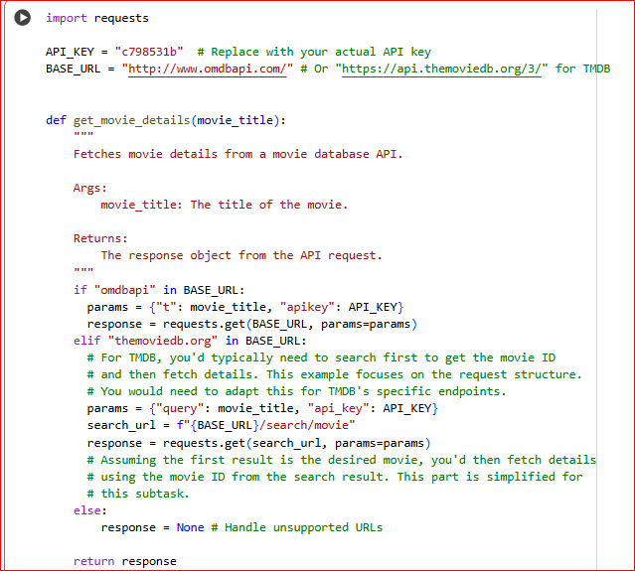

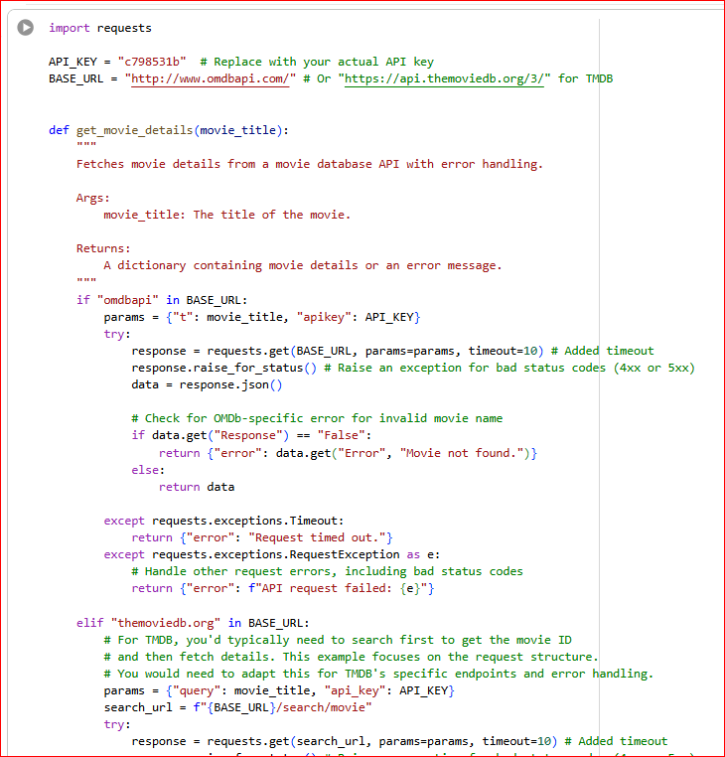

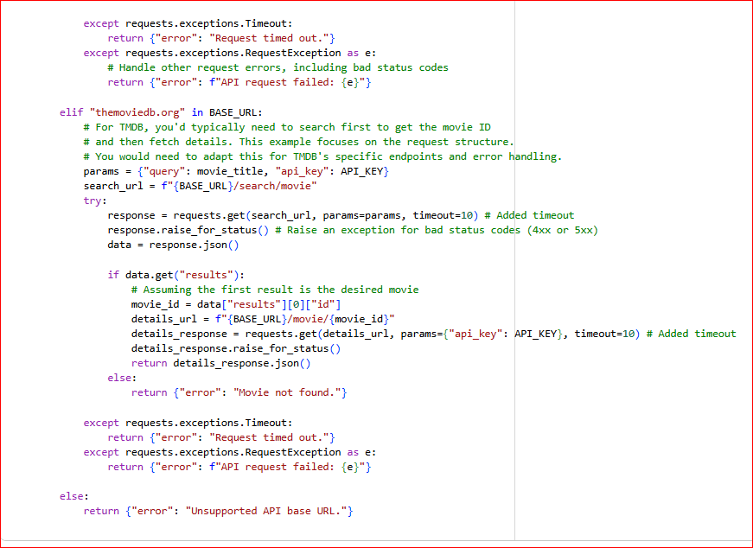

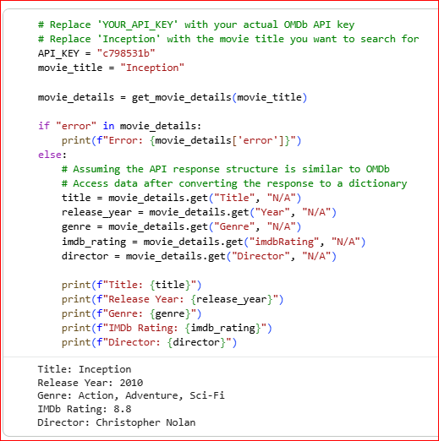

OBSERVATION:
installing the requests library, which is used for making HTTP requests to the movie database API.
Then, a function get_movie_details is defined to fetch movie details. This function takes a movie title as input and constructs the API request URL and parameters. It includes error handling for timeouts, general request exceptions, and specific errors from the OMDb API (like "movie not found").
Finally, it demonstrates how to call the get_movie_details function with a movie title. It checks if there's an error in the response and, if not, extracts and prints the movie's title, release year, genre, IMDb rating, and director.

Task 2 – Public Transport API
Task: Use a Public Transport API (e.g., city bus/train API or mock data) to fetch live arrival times.
Instructions:
- Fetch the next 5 arrivals for a given stop/station ID.
- Handle invalid station codes, unavailable service, and malformed responses.
- Display results in a readable table with route number, destination, and arrival time.
Expected Output:
- A script that provides real-time public transport information with robust error handling.

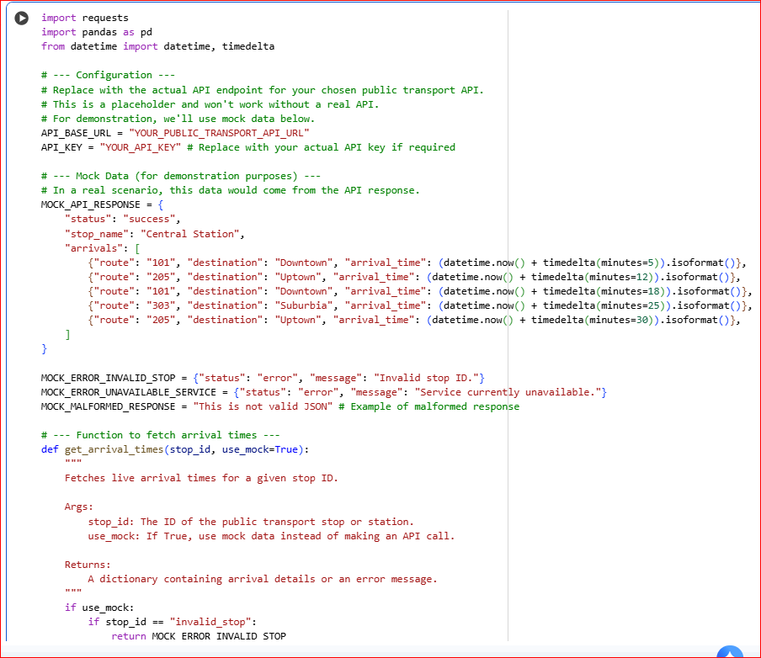
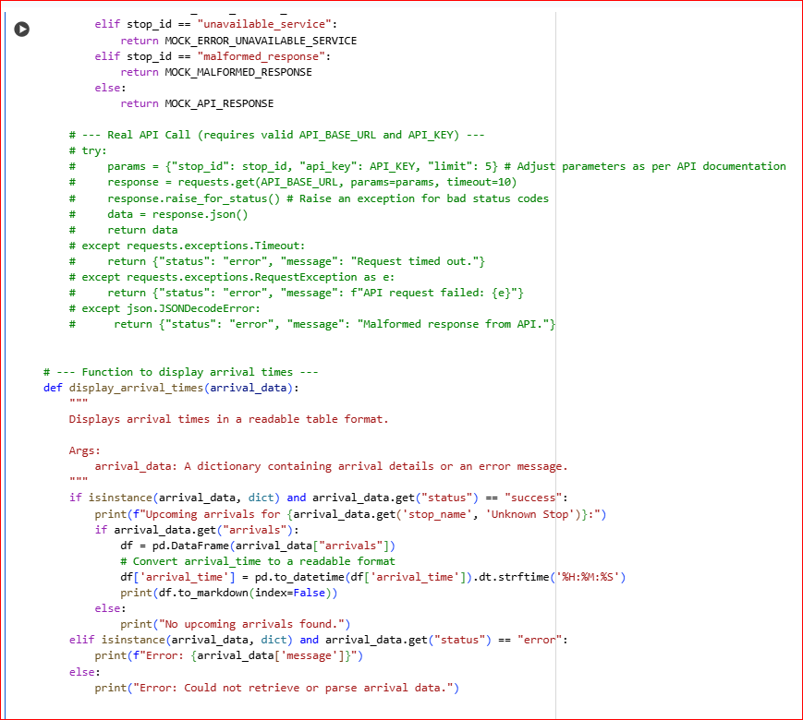

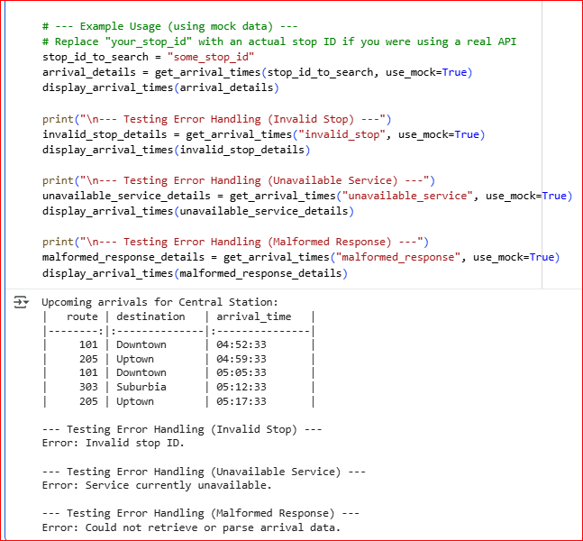

OBSERVATION:
- It imports necessary libraries: requests for making API calls, pandas for data manipulation and display, and datetime and timedelta for handling time.
- It defines placeholder variables for API_BASE_URL and API_KEY, which you would replace with your actual public transport API details if you were using a real API.
- It includes mock data (MOCK_API_RESPONSE, MOCK_ERROR_INVALID_STOP, MOCK_ERROR_UNAVAILABLE_SERVICE, MOCK_MALFORMED_RESPONSE) to simulate different API responses for demonstration purposes.
- It defines a function get_arrival_times that simulates fetching data. In the mock data mode (which is currently active), it returns different mock responses based on the input stop_id. There's also commented-out code showing how you would make a real API call using the requests library, including error handling for timeouts, request exceptions, and JSON decoding errors.
- It defines a function display_arrival_times that takes the data returned by get_arrival_times and displays it. If the status is "success", it uses pandas to create a DataFrame and prints it as a markdown table. If there's an error status, it prints the error message.
- Finally, the code demonstrates the usage of these functions with example calls, including testing the error handling scenarios using the mock data.

Task 3 – Stock Market/Financial Data API
Task: Connect to a stock data API (e.g., Alpha Vantage, Yahoo Finance) to fetch daily stock prices.
Instructions:
Prompt AI to generate Python function to query stock data by ticker symbol.
Handle API call limits, invalid ticker symbols, and null responses.
Display opening price, closing price, high, low, and trading volume.
Expected Output:
A Python script that fetches stock market data and handles failures gracefully.

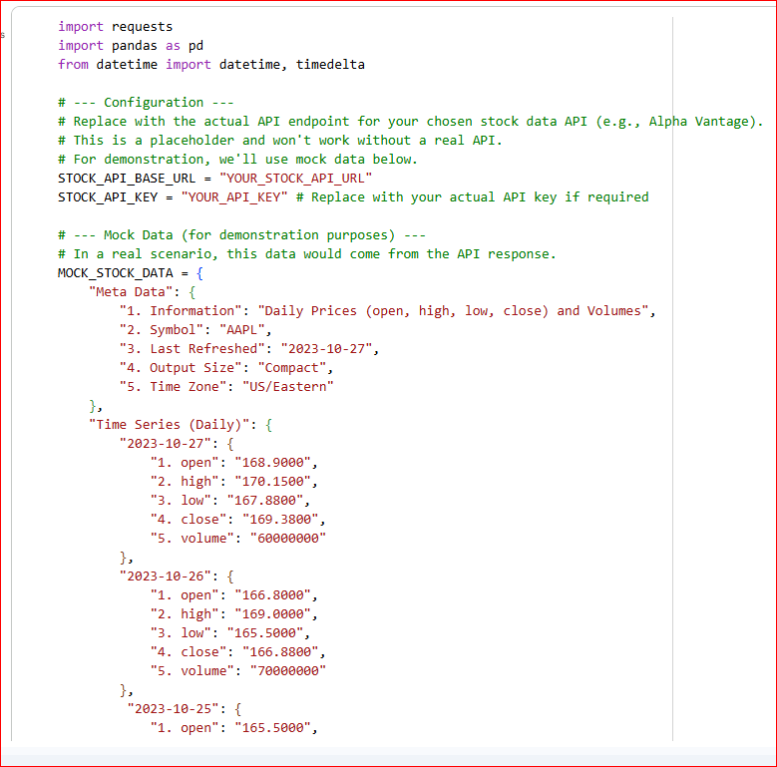
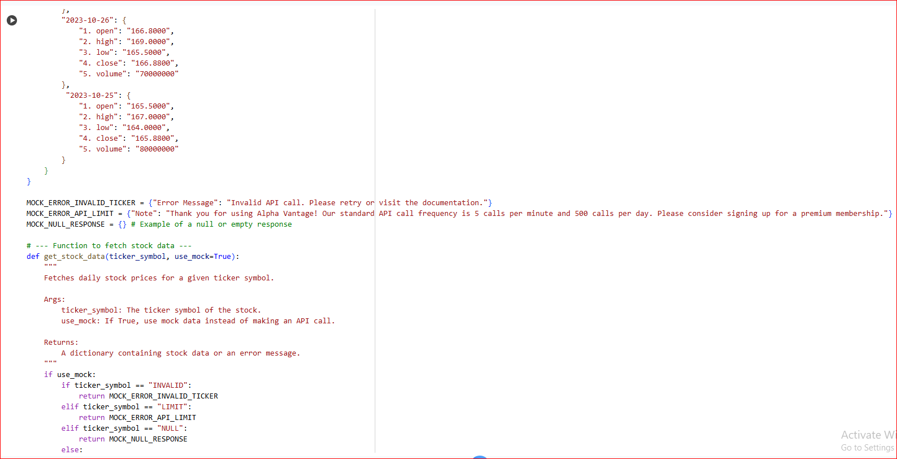
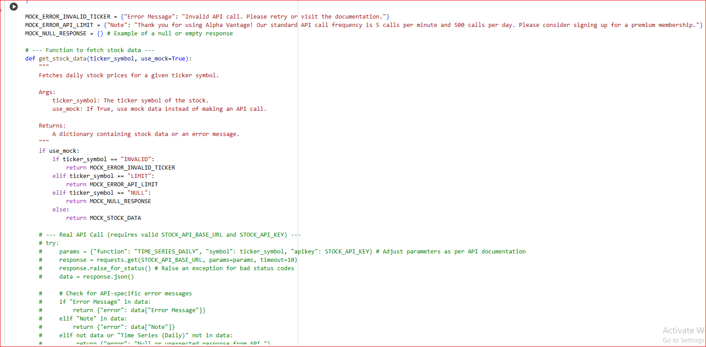

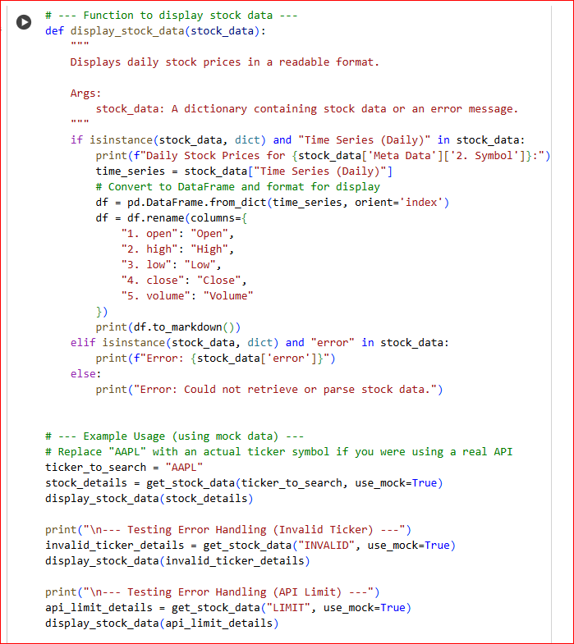

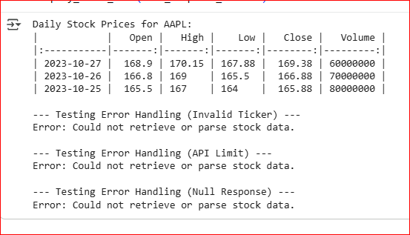

OBSERVATION:
- It imports necessary libraries: requests for making API calls and pandas for data manipulation and display.
- It defines placeholder variables for STOCK_API_BASE_URL and STOCK_API_KEY, which you would replace with your actual stock data API details if you were using a real API.
- It includes mock data (MOCK_STOCK_DATA, MOCK_ERROR_INVALID_TICKER, MOCK_ERROR_API_LIMIT, MOCK_NULL_RESPONSE) to simulate different API responses for demonstration purposes.
- It defines a function get_stock_data that simulates fetching data. In the mock data mode (which is currently active), it returns different mock responses based on the input ticker_symbol. There's also commented-out code showing how you would make a real API call using the requests library, including error handling for timeouts, request exceptions, and JSON decoding errors, as well as checking for API-specific error messages within the response data.
- It defines a function display_stock_data that takes the data returned by get_stock_data and displays it. If the response contains "Time Series (Daily)" data, it uses pandas to create a DataFrame from this time series data, renames the columns for readability, and prints it as a markdown table. If the response contains an "error" key, it prints the error message.
- Finally, the code demonstrates the usage of these functions with example calls, including testing the error handling scenarios using the mock data.

Task 4 – Real-Time Application: Translation API
Scenario: Build a translator using a free Translation API (e.g., Libre Translate, Google Translate).
Requirements:
Accept input text and target language from the user.
Handle invalid language codes, API quota exceeded, and empty text input.
Display original and translated text clearly.
Implement a retry mechanism if the API fails on the first attempt.
Expected Output:
A script that translates text to the specified language with strong error handling.
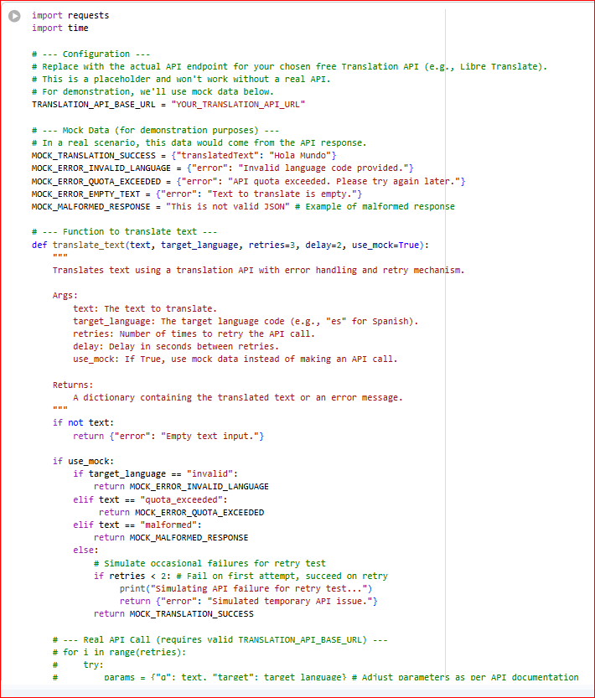
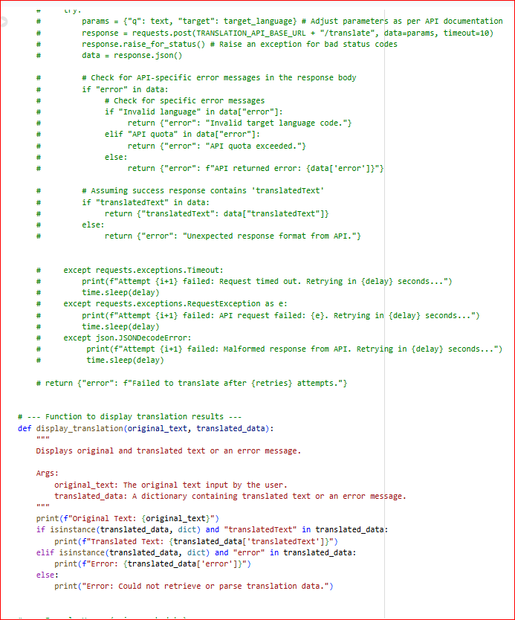
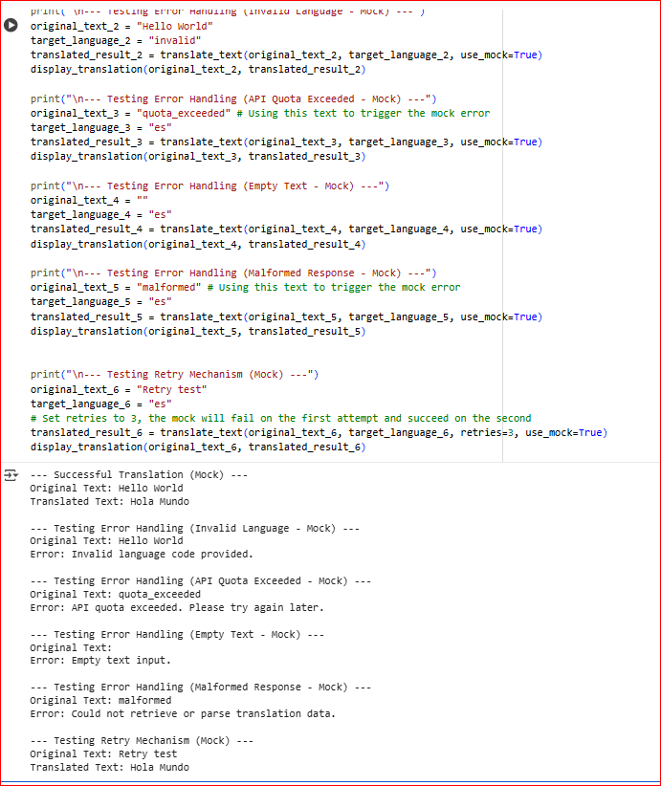
OBSERVATION:
The code contains a Python function translate_text that simulates calling a translation API using mock data. It handles errors like invalid language, quota limits, and empty input, and includes a retry mechanism. It also has a display_translation function to show the original and translated text or any errors. Example usage with mock data is included to demonstrate these features.

